# SE3050 – User Experience Engineering

## Lab Sheet 4

Plan and conduct user research.

# User Research Plan

Group ID: 2021S2_REG_WD_08

|  |  |
| --- | --- |
| **Student Reg. No** | **Student Name** |
| IT19114590 | G.Nivethika |
| IT19244044 | J.S.Samaratunga |
| IT19051376 | W.W.M.Anjana |
| IT19176802 | S.S.Eeswar |

## Introduction

Cargill's mobile app was conceptualized to be not just an e-commerce platform, but a complete overhaul of the grocery supply chain, ensuring convenience and guaranteeing customers get what they order. Cargills mobile app is not just a platform that has images of products for sale. It is a comprehensive end-to-end solution for customers to continue ordering groceries online,

building on the trust and legacy of Cargills and establishing e-grocery as a viable alternative to the conventional brick and mortar store.

We are planning to do usability testing on Cargill's mobile application to test how easy Cargill's mobile application is to use with a group of representative users. We are planning to test the user interfaces, user-friendliness of the app and the process flow of each functionality through this user research. Through this user research, we will be able to understand how people go about performing tasks and achieving goals that are important to them. It gives us context and perspective and puts us in a position to respond with useful, simplified, and productive design solutions.

So, using the results of user research, we can find out the problems users face when using Cargill's mobile application and current features that need to be improved. So, by using these results we will make good design decisions and develop a new optimal mobile application for the users.

Test Objectives

* I want to test whether there are any usability issues in the current account creation flow?

I think the users won't find any problems in creating an account.

* I want to test whether users can easily navigate to different product categories?

I think the users can easily navigate through product categories.

* I want to test what do users think of the local ads' looks and feel?

I think the user thinks of them as attractive.

* I want to test whether the payment process is easy and quick and whether the user thinks it is secured?

I hope the user thinks the payment process is secured and can do easily

* I want to test whether the users can easily find the product they need?

I hope users can find the product easily.

* I want to test whether the users can easily find the search box?

I think the users can find the search box easily.

* I want to Identify whether all the interfaces of the app are user-friendly and attractive?

I think the users think all the interfaces are user-friendly and attractive.

* I want to test whether the delivery process can be easily done?

I hope the user thinks the delivery process can be done easily.

## Methodology

We have conducted our user research as a user interview and a Survey using Google form.

After selecting two personas, we contacted two users related to them for the user interview. As our selected users are already familiar with the Cargills online application we have organized our interview questions accordingly. Considering the current pandemic situation, we decided to contact them via zoom call at their remote location. A mobile phone or a laptop with internet access and having the zoom application installed are our technical requirements to conduct the user interview.

For the survey we have used google forms as our platform and designed a questioner to be distributed among the community who are familiar with technology. In our questioner we have arranged a set of general questions as well as function related questions.

We were able to gather qualitative data from the user interview and quantitative data from the survey. After successfully conducting the user research, it gave us a clear idea about the confusions and frustrations faced by users while using the Cargills online mobile application.

### Interviewing

We have conducted our user research with the help of Zoom application. Two separate interviews were organized with the presence of app users as mentioned above. All our group members joined the zoom meeting and two members questioned the users. As they questioned the users, other members took notes and observed the user behavior/expressions while answering the questions.

Both our interviewees had past experience using Cargills application so have organized our interview script aiming to evaluate their user experience. User interviews were conducted according to a prepared script which included both general and functional questions related to the user experience. Both user interviews were conducted according to the same script as given below.

**Interview script**

Introduction

Hi, I am <interviewer name>. We are conducting user research as part of our project to design an eCommerce app So I would like to ask you some questions about your experience when it comes to purchasing goods using Cargill's app. You don't have to answer any questions you are not comfortable with and there are no right or wrong answers. Do you have any questions before we begin?

What you say to us is important to us, so we’d like to take notes. To make sure our notes correctly represent what you say, we would also like to take a video/sound recording. Of course, the recording is confidential and will not be shared around. If you have no objections, we’ll proceed with the questions?

General questions

1. First of all, I would like to know a bit about yourself, only if you are comfortable sharing with us?
2. On an average day when do u first start using technology?
3. When was the last time u used Cargill's app?
4. Why do you shop online?

Specific/functional questions

**Home page and Items page**

1. Is there anything you look for in the process of adding items to the cart in Cargill's app and that is missing or hard to find?
2. What do you think about the home page?
3. Under what circumstances would you want to receive an alert in the process of adding items to the cart in the application?

Can u please elaborate it more?

**Place order and delivery process**

1. What are your main concerns regarding the delivery process of this application, if you were to place an order?
2. What alternative methods would you recommend to complete the delivery process of this application.

**Shopping cart and payment process**

1. Do you notice any potential problems regarding view cart or Add to cart process on this app? If so, what?
2. Was there anything missing from payment process of this app that you expected?

**Login, Registration and User profile**

1. While you are in the Signup process do you face any difficulties or common issues? If so, can you explain briefly?
2. Is there suggestion to improve the Sign In process as user of the Cargills App?
3. What do you think about the User Profile and its design?

Ending interview

That's the end of the questions.

I am grateful for interviewing with you today. You have given me a clear overview of the problems regarding the Cargill online shop app.

May I contact you if we have any other questions or for possible further research for this project?

Thank you for your valuable contribution. It was really helpful.

### video recording

User interview was recorded using the zoom application. Before we started with the interview questions, we explained our background and asked for permission from the user to take a video recording as a reference.

Interview video link:

<https://web.microsoftstream.com/video/6a5033f8-7403-411d-8eb8-1f294dab62a5>

### Questionnaire

We have designed a questioner to be distributed among the community used google forms as our platform. In our questioner we have arranged a set of general questions to identify the targeted audience and other questions were designed related to the Cargills online application.



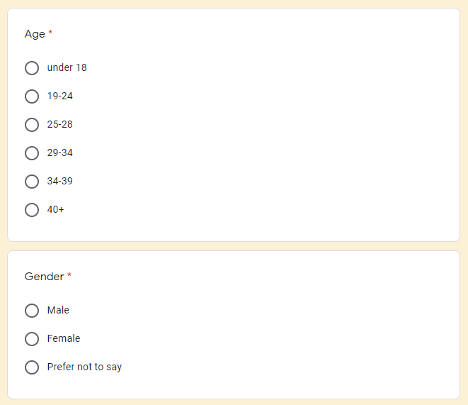

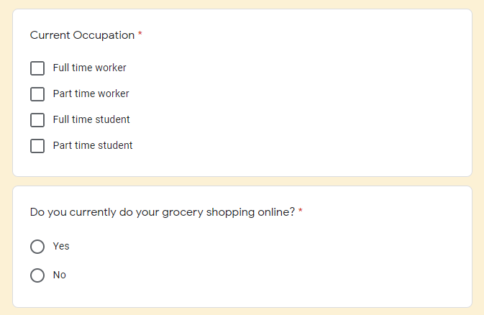

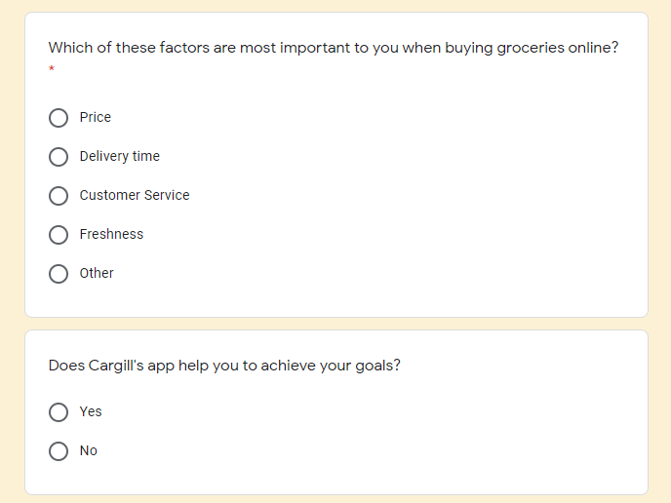

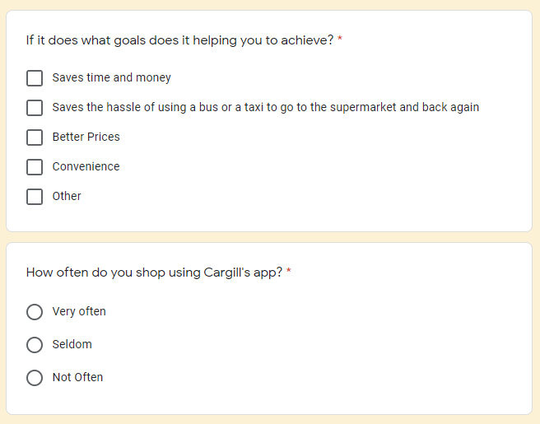



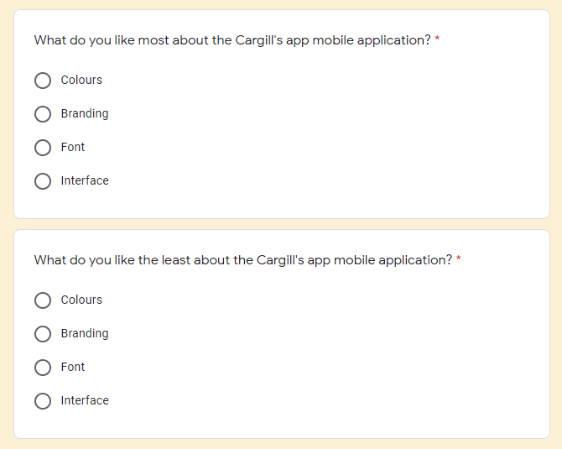

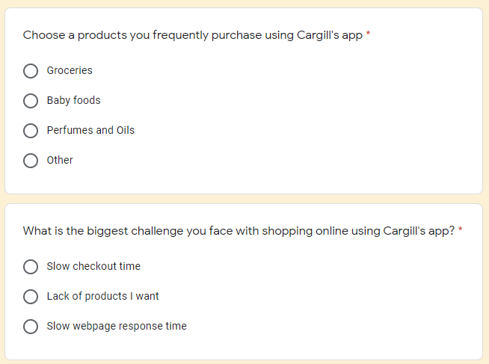

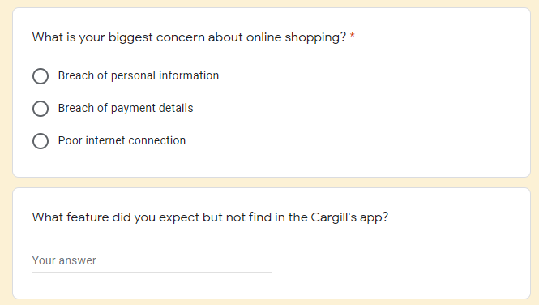

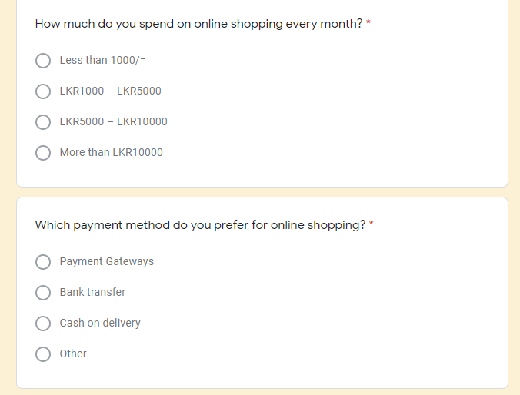

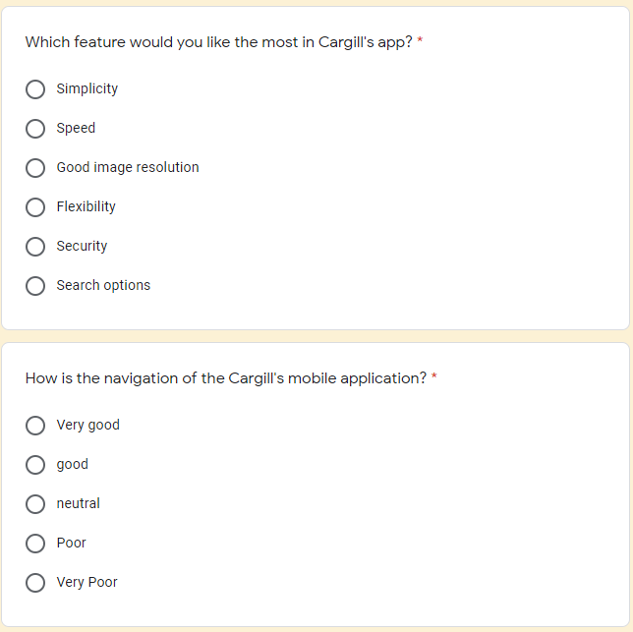



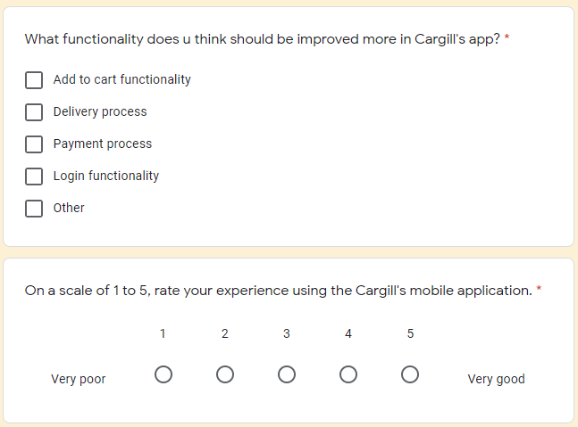

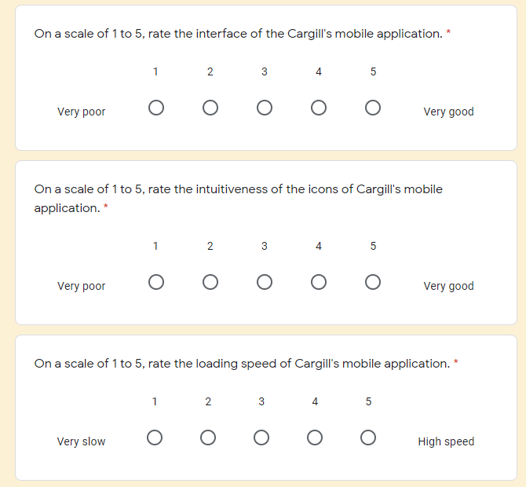

## Participant Profiles

The table below provides a breakdown of the participants selected for testing:

|  |  |  |
| --- | --- | --- |
| Name | Demography | Location, Date and Time |
| *Prasad Ravikumar*  *Surya Sivakumar* | He is 25 years old and has been working as a Software engineer at Company Virtusa. He usually goes to the gym thrice a week and he is a person who takes health seriously.            He is a 25year old IT undergraduate, the part-time worker at Metrix IT company.  He is currently living with his parents and he prefers spending time at home rather than going out. | Location:-Remote location connected via zoom  Date:-8/20/2021  Time:-6pm  Location:- Remote location connected via zoom  Date:-8/20/2021  Time:-5pm |

### User Research – Tasks/Scenarios

|  |  |  |  |
| --- | --- | --- | --- |
| **No** | **Task Instruction** | **Target** | **Probes** |
| 1 | Try to sign up a new account with invalid email address. If you are already logged in to your account, you need to logout first to try this one. | To check whether user notices, there is not any email validation message pop up. | The user couldn’t signup to the system. But he expected validation message. |
| 2 | Try to sign up a new account with password which character length is below 3. If you are already logged in to your account, you need to logout first to try this one. | To check whether user notices, there is not any password validation message pop up. | The user signup to the system successfully. |
| 3 | Now assume, you have been forgotten your password and you need to reset password. So please follow the steps according to UI. | To check whether user notices, it would take a long time to receive verification code. | The user was waiting long time to receive verification code |
| 4 | Try to type product related keyword on the search bar and search items. | To check whether user notices, taking sometimes to display searched items. | The user was waiting sometimes to get the searched items. |
| 5 | If you are not logged in to your account, please log in. Then select few items on the search list and add them into the cart. | To check whether user notices, there is not any confirmation alert displayed. | The user completed the task successfully. But the user double clicks the add to cart button for check whether item was already added or not. |
| 6 | If you are not logged in to your account, please log in. Then add some items into the cart. After that explore the cart items and remove some item from the cart. | To check whether user notices, there is not any button to remove specific cart item. | The user was confused to do that task. He was unable to remove item immediately. |
| 7 | If you are not logged in to your account, please log in. Then add some items to the cart. And after select the specific item from the cart, Checkout the selected items. | To check whether total amount of the checkout items clearly visible for the user. | The user completed the task without any confusion. |
| 8 | If you are not logged in to your account, please log in. Then select a product on the product list. And after select card payment as the payment method. Then fill the form of the card details. | To check whether user notices, there is not any validation message for separated input field. | The user completed the task successfully, but he was confused to find which input fields are incorrect. |
| 9 | If you are not logged in to your account, please log in. Move the pin to exact delivery location and click on the select location. | To check whether the user will be able to pin the exact delivery location on the map. | User gets an alert message saying please select address. User is confused on how to complete the task and fails to pin the location on map. |
| 10 | If you are not logged in to your account, please log in. Try to type the search address in the search bar to get the location on map. | To check whether user notices, that its taking some time to map the exact location. | User was waiting some time till the map location loads. |

## Plan for Data analysis

|  |
| --- |
| Is there anything you look for in the process of adding items to the cart in Cargill's app and that is missing or hard to find?   * User 1 : Hard to find the search bar. Because it’s palced bottom of the interface * User 2 : Buy now button is not available |
| What do you think about the home page?   * User 1 : In the Home page deals and festure products are missing * User 2 : Search bar and cart icon should be place on top of the Home page |
| Under what circumstances would you want to receive an alert in the process of adding items to the cart in the application?   * User 1 : Need a notification message when adding an item to cart * User 2 : Have pop-up message of notification when changing quantity of the product |
| What are your main concerns regarding the delivery process of this application, if you were to place an order?   * User 1 : Delivery method and notification of delivery time * User 2 : Delivery to exact location and schedule of delivery time |
| What alternative methods would you recommend to complete the delivery process of this application?   * User 1 : Use a map view to mark the delivery location * User 2 : Ablity to schedule the time of delivery by the user |
| Do you notice any potential problems regarding view cart or Add to cart process on this app? If so, what?   * User 1 : No any delete button for related cart items. * User 2 : Visibility of the total amount of the selected items is not clear |
| Was there anything missing from payment process of this app that you expected?   * User 1 : Notification should be meaningful * User 2 : Feature to Save the card details for future purchasing and unique error validation notification for corresponding input field of the card details form |
| While you are in the Signup process do you face any difficulties or common issues? If so,can you explain briefly?   * User 1 : OTP verfication should be automated * User 2 : Validate the email address and if there any errors notify them before submit |
| What do you think about the UserProfile and it's design?  User 1 : Can not change mobile number and email address. Also in profile is it require unneccessary details  User 2 : Inside the profile can not able view NIC number, can not able to mange the address and phone number can not editable |
|  |
|  |
|  |
|  |
|  |
|  |
|  |
|  |
|  |
|  |
|  |
|  |
|  |
|  |
|  |
|  |
|  |
|  |
|  |